CREATIVE AFFIRMATIVE ORGANIZATION PARNASSUS, Novi Sad, Serbia
ASSOCIATION SPIRIT, Rijeka, Croatia
HUMANITARIAN ORGANIZATION „Partner“, Banja Luka; Bosnia and Herzegovina
NGO „ART 365“, Podgorica, Montenegro
are announcing
OPEN CALL FOR FILM COMPETITION
For 21. INTERNATIONAL FILM FESTIVAL

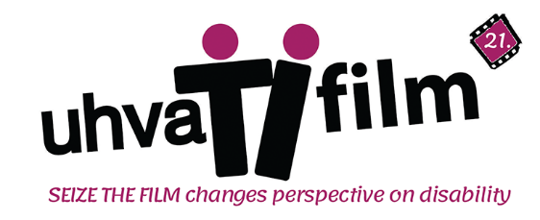
on the topic of disability and films whose authors (actors, screenwriters, directors)
are persons with disability-disabled persons

Film Festival “Seize the Film“ is focus on projections of films related to the topic of disability and it has editions in Novi Sad (Serbia), Rijeka (Croatia), Banja Luka (Bosnia and Herzegovina,) and Kotor (Montenegro).

In addition to screenings of films on the topic of disability, the Festival also has accompanying programs and post-production - Film Caravan, which includes screenings in cultural spaces, schools, other festivals and „Seize the film Kids“ - screenings of films suitable for children aged 7-12 (in Serbia).

TERMS:
- Topic: Disability*
- PLEASE NOTE THAT we DON'T accept films about COVID 19 unless the film is about a person with a disability who had Covid 19, the challenges of people with disabilities at the time of the pandemic, or disability as a postcovid symptom.
- up to 30 minutes
- At least DVD quality**
- ENG or SR/HR subtitles; We especially appreciate it if your subtitles are SDH - descriptive (for deaf or hard of hearing audiences, other sound details are described as well as words to help the audience understand the action or mood of the scene. For example, an SDH subtitle might read "sad music is playing" or "slurred babbling.")
- Dialog list or srt file is required to be sent via email to uhvatifilm@gmail.com if/when we ask for it.

Films must be sent latest 10.04.2023. Applicants will bear all expenses and risks of sending the materials.
Films and copies remain with organizers. Organizers are obligated not to use films for any commercial purposes. For screenings of the chosen films for the competition and review part, organizers will not pay fees for the authors or producers. Organizers hold the right of using trailers or film clips up to 3 minutes, exclusively for the purpose of promotion for the Film festival „Seize the film!“.
The main program of the festival (Films selected and awarded by the jury, panel discussions with the authors/actors) will be held in in Novi Sad (Serbia) during 21.th Film festival „Seize the film!“. Film program will be held in period October 11th- October 15th 2023.
Films that are selected and presented at the 21th Film Festival "Seize the film!" in Novi Sad (SR) enter the shortlist for presentation in Rijeka (Croatia), Banja Luka (Bosnia and Herzegovina) and Kotor (Montengro) but also in our post-production programs.

Best films will be rewarded with a plaque and will be directly placed at the Festival of European documentary and independent film “Euro-In”, which is held in Novi Sad.

In addition to rewards for best film, best scenario, and best directing, an expert jury will award special prizes for the contributions to the field of disability having in mind:
- Does/how much does the film provide the alternative/different view on disability
- How original is their approach to the topic of disability
- How interesting is the movie/attracts attention/is impressionable
- How well disability stereotypes were avoided
- How much does the film provide information regarding disability
Some films may not be selected for the film program Uhvati film Novi Sad, but they can be part of Uhvati film Kids. Authors will be directly informed about this.
If films are submitted via Filmfreeway, festhome, clickforfestivals an application form is not required.
If films are submitted directly via youtube, Wetransfer, or Vimeo, the application form is required. Also, it is required on our email uhvatifilm@gmail.com to send:
- at least 2 film stills (max 5)
- dialog list/.srt
- trailer (promo clip) if any (or download link)
APPLICATION FORM download link

uhvatifilm.org

